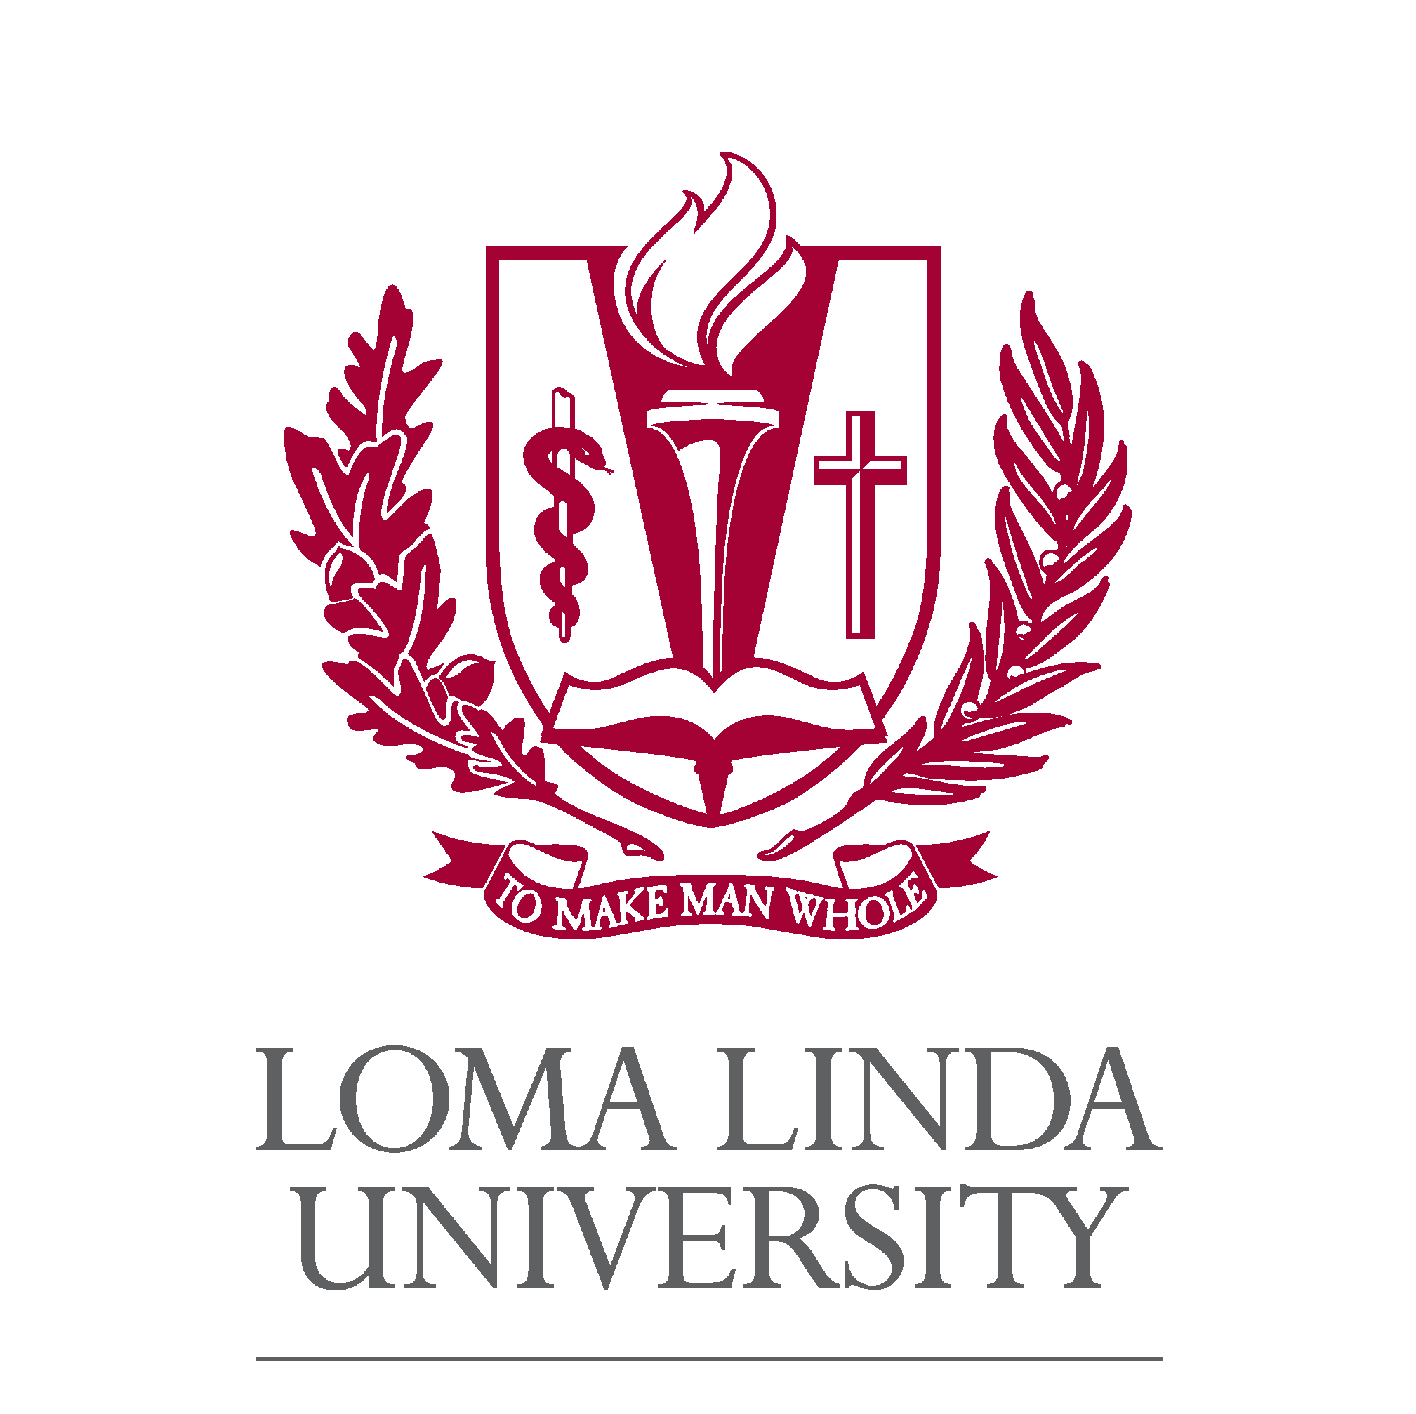
LOMA LINDA UNIVERSITY
PHARMACY RESIDENCY PROGRAMS
Application for Post Graduate Year Two (PGY2)
Medication-Use Safety & Policy Residency

APPLICANT INFORMATION
Last  Name | First  Name
Address
City | State/Zip
Telephone  Number | Email  Address

This application form: open until filled
In addition to this form, please include:
- A letter of intent describing your background, experiences and how a residency program will benefit your professional growth
- Curriculum vitae
And the following application materials
- An official academic transcript sent directly from all Colleges of Pharmacy attended
- Three letters of recommendations along with recommendation forms sent directly from your reference
Please send references to:
Huy Le, PharmD,
Medication Safety/Pharmacy Quality Management Coordinator
Loma Linda University Medical Center
11234 Anderson Street
Loma Linda, CA 92354
Phone: (909) 558-4000, Ext 83885
Email: hle@llu.edu

List all colleges/universities attended
Name of College/University | Degree
Dates Attended
Name of College/University | Degree
Dates Attended

List of References
Please list the names, titles, and addresses of the individuals whom you have requested to send letters of reference.
1. Name | Title/Affiliation
Address
2. Name | Title/Affiliation
Address
3. Name | Title/Affiliation
Address

